Heart attack victim has experimental surgery to inject stem cells from his HIP into his heart to help the organ repair itself
After James Cross had a heart attack in February, he was given a unique chance for a new life.
Surgeons at the London Chest Hospital offered the 55-year-old experimental therapy that involved injecting his own stem cells into the damaged organ.
This was done in the hope that it would encourage his heart to repair itself.
The injected stem cells should prevent the heart’s muscle tissue from becoming increasingly damaged after suffering a lack of oxygen during the heart attack.
And it seems to have worked.
‘After the heart attack, I had 21 per cent of my heart muscle functioning, as opposed to the normal 61 per cent,’ says James.
‘When I was tested a few months ago, that figure was up to 37 per cent and I believe it’s still improving.’
Researchers behind the new technique hope it will increase the survival rate from heart attacks by a quarter.
James, from Hornchurch, East London, is now back working at his family landscaping business with his sons, Jimmy, 31, and Danny, 28, and goes to the gym regularly.
His treatment is the latest in a new wave of stem cell therapies that could become everyday treatments for many conditions.
Stem cells have been discussed for more than 15 years as a future ‘cure’ for many ills. But concerns about the use of stem cells taken from embryos slowed up their introduction.
These issues have been overcome, mainly because scientists have discovered how to transform adult patients’ bone marrow cells into stem cells.
So now they are being used in a multitude of ways.
Surgeons now use stem cells as a treatment for strokes, blindness, cancers and arthritic hips and knees, as well as a way to grow artificial blood for emergency transfusions.

Stem cells — the basic ‘building block’ form of the cells that make up our bodies — are capable of developing into different tissue types, and those from bone marrow can now be made to grow, or ‘differentiate’, into heart muscle cells.
When James was offered the chance to try the new treatment it seemed too good an opportunity to turn down.
Before his heart problems, James ate healthily, drank only occasionally and never smoked. But he had suffered extreme emotional trauma.
‘The medical team believe that the heart attack was caused by the stress of seeing my 16-year-old son, Sam, die in a light aircraft crash at Southend airport in 2006,’ he says.
‘I used to go to bed crying and wake up crying.’
On the night of the heart attack, James awoke at 2am with pain in his left side.
When it intensified, his wife Yvette, 52, drove him to A&E. He was then taken by ambulance to the London Chest Hospital, where an emergency team waited.
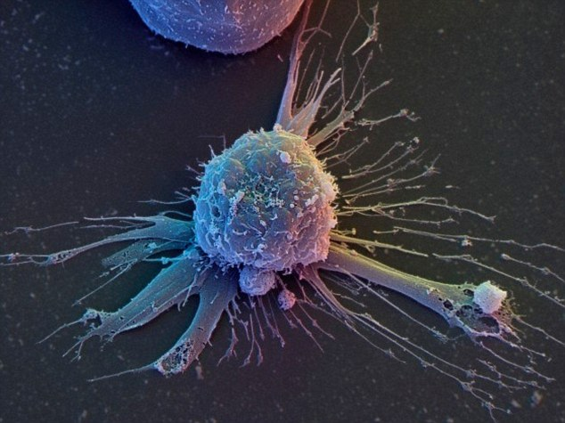
+3
Surgeons at the London Chest Hospital injected stem cells, pictured, from Mr Cross's hip into his heart in the hope that it would help the organ repair itself. The treatment appears to have worked and Mr Cross's heart muscle function has improved from 21 per cent after the attack to 37 per cent and it is still improving
‘I was petrified,’ James says. ‘I had an out-of-body experience, where I saw my dead son and my father looking at me, shaking their heads, as if to say it wasn’t my time.’
The surgical team inserted a small tube called a stent into the narrowed coronary artery, which was causing the heart attack, to widen it and restore blood flow.
A day later, James was visited in the intensive care unit by experts seeking the first patients for their heart stem-cell experiment, called the bone marrow acute myocardial infarction trial (BAMI).
James was among the first of 3,000 participants in a Europe-wide study. All are to be treated within five days of a heart attack in the hope of increasing survival rates.
‘I was only the second person in the UK to have had it done,’ says James.
I was the only person in the UK to have had it done. It hurt for a second... but it was fine once the needle was in fully
‘The morning after, they came and took bone marrow from my hip to obtain my stem cells.
‘It hurt for a second, despite the anaesthetic, but it was fine once the needle was in fully.’
The next day surgeons put a tube into a wrist artery and ran it into his heart. They injected a syringe of stem cells, then stopped the blood supply to his heart for a second, so the stem cells would be deposited there.
‘They did this seven times with seven syringes. I was awake all the time, and it wasn’t traumatic,’ says James.
Within hours, he was up and about. Now he feels entirely recovered.
The BAMI study aims to see if it is a result of the stem cell injections, or whether James may have recovered this way anyway.
But James, who will be monitored for five years after the treatment, is convinced he’s benefited. ‘I feel brilliant,’ he says.
Anthony Mathur, director of cardiology at Barts Health NHS Trust and professor of cardiology at Queen Mary University, is the BAMI chief trial co-ordinator.
He says it will be four to five years before doctors know definitively whether adult stem cells from bone marrow can repair damaged hearts.
Elsewhere in London, surgeons are pioneering stem cell therapy for stroke patients.
Last month, the researchers from Imperial College London reported that all five patients in the trial were alive and three were living independently at home six months later.
Four of the patients had the most serious type of stroke.
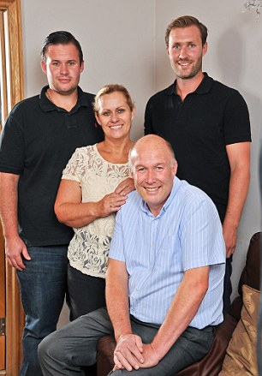
+3
Mr Cross, pictured with his wife Yvette and sons Jimmy and Danny, will be monitored as part of the study for five years
Normally, only one in 25 such patients is able to live independently after six months.
Each had stem cells extracted from their bone marrow. These can grow into blood cells and cells that line blood vessels. The stem cells were injected into an artery supplying blood to the brain.
Scans of patients’ brains found that damage caused by the stroke had reduced over time, although similar improvements may also be seen in stroke patients as part of the normal recovery process.
A handful of UK patients have had stem cell treatment to restore sight to one eye that had been damaged or blinded by trauma.
This is done using cells taken from their good eye.
‘We have performed this on 25 patients, and in all cases it has been successful, with patients experiencing a significant reduction in visual impairment,’ says lead researcher Francisco Figueiredo, professor of ophthalmology at the Royal Victoria Infirmary in Newcastle and Newcastle University.
Meanwhile, surgeons at Southampton General Hospital are injecting stem cells and ‘biological glue’ into patients who have torn the cartilage in their hips and knees.
It is hoped the stem cells can save joints from developing arthritis or needing to be replaced.
Dusko Ilic, senior lecturer in stem cell science at King’s College London, says: ‘We are still in very early days. The best successes have been with very simple tissues, such as cartilage.
‘It will take five to ten years before we really understand what can be done in the future. I don’t think we’ll ever be able to use stem cells to regenerate all the organs and tissues of a human.’
Nevertheless, lab studies on animals indicate there are still further possibilities for future stem cell therapies.
For example, Stanford University investigators have taken skin cells from three infertile men and converted them into stem cells.
When transplanted into the testes of mice, these cells developed into early-stage human sperm cells. The research shows it may be possible to restore male fertility by injecting cells into infertile men’s testes.
And, at the University of Utah, treatment with human stem cells has allowed mice crippled by a version of multiple sclerosis to walk again after less than two weeks.
A similar outcome in humans could help patients in potentially disabling stages of the disease, says the study in the journal Stem Cell Reports.

